**Kubernetes Assignment – 1**

● Deploy a Kubernetes Cluster for 3 nodes

● Create a nginx deployment of 3 replicas

Creating 3 node Cluster:

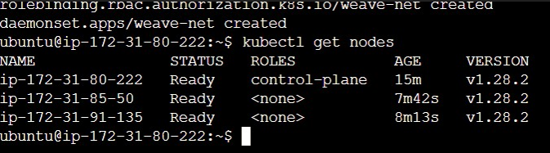

And it’s replica’s with nginx:

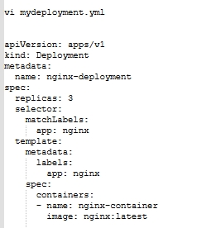



**Kubernetes Assignment – 2**

● Use the previous deployment

● Create a service of type NodePort for nginx deployment

● Check the nodeport service on a browser to verify

Nodeport Service created for nginx deployed earlier:

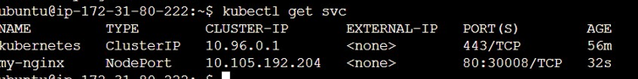

Able to see nginx on browser:

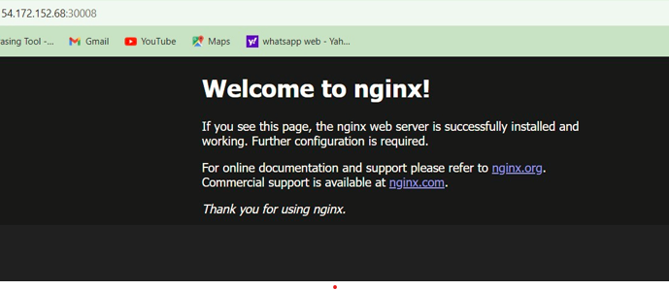

**Kubernetes Assignment – 3**

● Use the previous deployment

● Change the replicas to 5 for the deployment

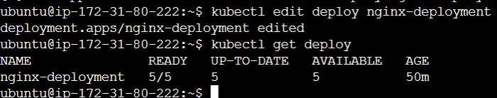

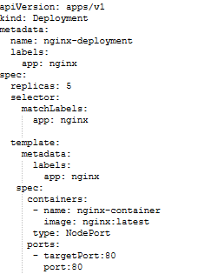

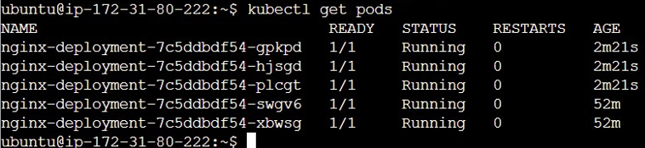

**Kubernetes Assignment – 4**

● Use the previous deployment

● Change the service type to ClusterIP

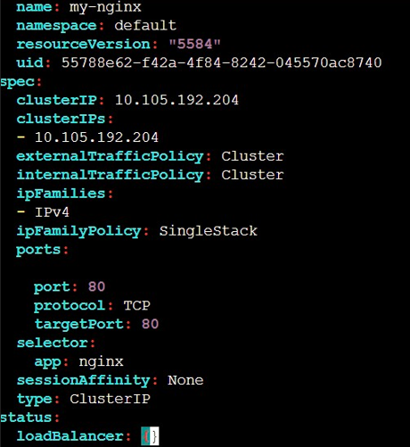

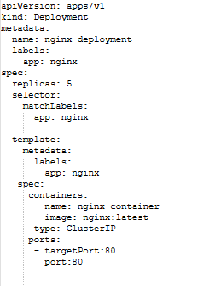

**Kubernetes Assignment – 5**

● Use the previous deployment

● Deploy an nginx deployment of 3 replicas

● Create an nginx service of type clusterip

● Create an ingress service /apache to apache service /nginx to nginx service

Editing Replicas to 3 from previous deployment of 5.



Creating nginx service of type ClusterIP:

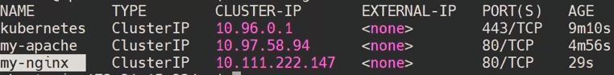

Creating Ingress Service:

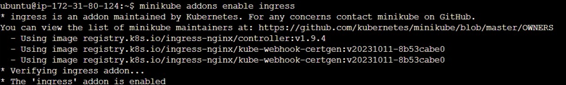

Creating Apache service below:

